Bassenthwaite Parish Council

Village Green Policy

Definition of a Village Green

This is defined in Commons Registration Act 1965 as amended by The Countryside and Rights of Way Act 2000, as ‘land which has been allotted by or under any Act for the exercise or recreation of the inhabitants of any locality have a customary right to indulge in lawful sports and pastimes, or which falls within subsection (1A) of this section as follows:
Land falls within subsection 1A if the land is land on which for not less than 20 years a significant number of inhabitants of any locality, or of any neighbourhood within a locality have indulged in lawful sports and pastimes, as of right’.
The Bassenthwaite Village Green are the areas in the middle of the Village as covered by the below map:
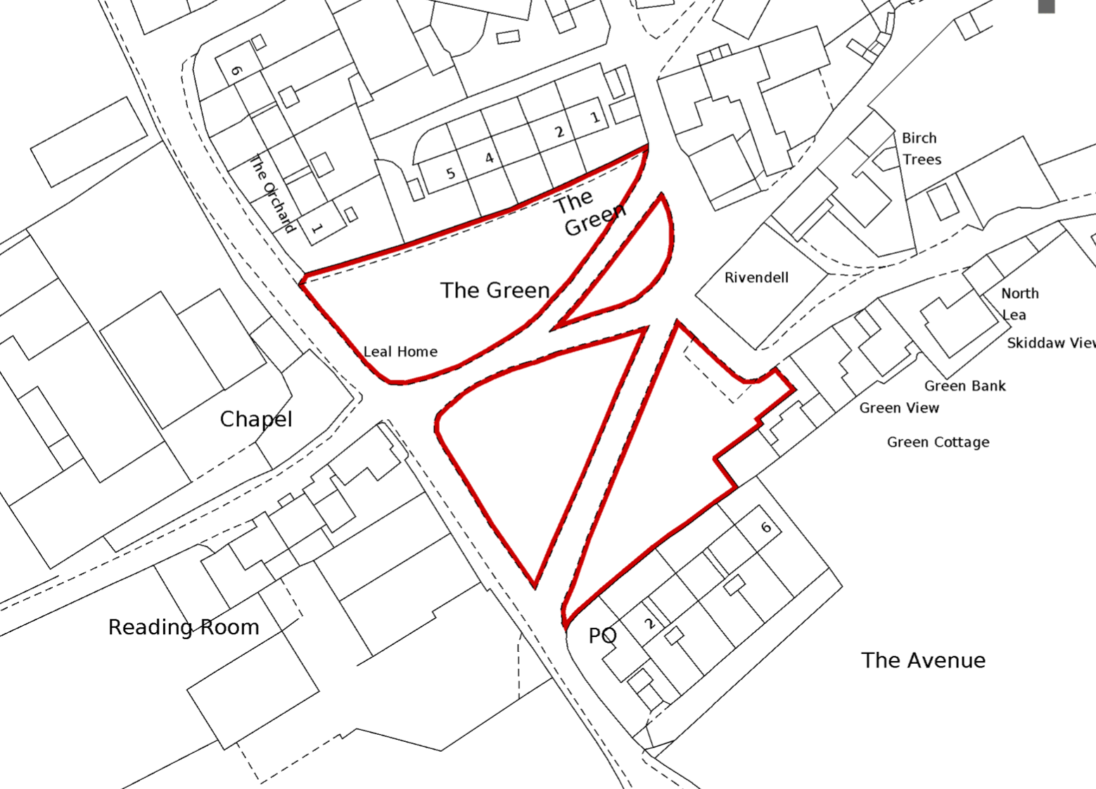

Registration
Bassenthwaite Village Green is registered with the Commons Registration Authority for Cumbria (formally Cumbria County Council, now Cumberland Council). This provided protection to this area of land as afforded by a number of pieces of legislation that cover all aspects of the Village Green’s use and management.
The ownership of Bassenthwaite Village Green was vested into the ownership of Bassenthwaite Parish Council by the Commons Commissioner on the 18th July 1979.
- Legislation
The below is a list of the most common legislation which currently exists for the protection and rights relating to Village Greens:
- The Commons Act 1876, 1899 and 2006
- The Open Spaces Act 1906
- The Acquisition of Land Act 1981
- The Law of Property Act 1925
- Occupiers Liability Act 1957
- The Countryside and Rights of Way Act 2000
- Local Government Act 1972 (and others)

- Responsibilities

Village Greens are managed and administered by Bassenthwaite Parish Council, who are responsible for the maintenance, protection and upkeep. All matters relating to the Village Green should be referred in the first instance to the Parish Council for consideration.
Any ruling or actions will be made by them in accordance with the present legislation and their own policies and procedures, or referred to other Authorities as deemed necessary by them.
As custodians of the Village Green the parish Council must ensure the Village Green is protected against:
- Encroachment
- Damage
- And uses other than those consistent with the normal enjoyment of a Village Green.

Driving, cycling, motorcycling, or parking of any motorised or horse drawn vehicles on any part of the Village Green is not permitted.
No horse riding nor grazing of livestock is permitted.
Maintenance and repairs relating to the Village Green will only be carried out by contractors appointed to carry out such works by the Parish Council.
- Lawful & prohibited uses

The below is not exhaustive, but below is a list of lawful/prohibited uses for Bassenthwaite Village Green.
Lawful Uses:
- Walking & dog walking
- Playing informal sports and pastimes

Lawful Uses subject to (prior consent, insurance and risk assessments required):
- Public gatherings for entertainment
- Village Fetes
- Carol singing and maypole dancing

Prohibited uses (without express written consent from the Parish Council):
- Any physical alteration to the Village Green including altering the surface of the greens
- Fencing of the green, or making it inaccessible to the public
- Wilful damage, e.g. from vehicles, horses or bikes
- Driving or parking of any motorised or horse drawn vehicle or bike/motorcycle
- Grazing of cattle, sheep, horses or other animals
- Pruning, cutting down, planting, or removal of trees or shurbs unless at the express request or consent of the Parish Council

Prohibited:
- Building of any temporary or permenant structure
- No fires, camping or caravanning nor overnight stays
- Any action that would effect a physical alteration to the green.

Uses which could cause damage to property or people or are likely to be a danger or nuisance to other users of Bassenthwaite Village Green such as flying of model aircraft/drones etc will not be permitted.

Dogs must always be controlled and kept on a lead where appropriate.

Any rubbish generated by users of the Village Green must be removed by the user.

- Permission process

Any event whether open to the public or not will not be consented unless prior written approval has been requested from (and granted by) Bassenthwaite Parish Council.

Permission requests will only be accepted when accompanied by:

-Risk assessment from the user/lead user
-Evidence of appropriate public liability insurance.

Permission should be applied for in writing to Bassenthwaite Parish Council via bassenthwaiteparishclerk@hotmail.com at least 2 months in advance of the event being scheduled.

All requests must detail the exact nature of the event to take place, likely levels of attendance.

This process applies to ALL usage of the Village Green other than personal enjoyment, this includes:
- Village Fete
- School Sports
- Sports Day
- Community Events
Permission will not be granted for events that are for commercial gain (either private sector or personal)

- Responsibility for safety etc at events

The safety and welfare of those attending an event is the responsibility of the named lead user throughout the event and this includes:

- Ensuring the event is properly supervised
- Ensuring that local residents are not troubled in anyway (e.g. bright lights, loud music etc)
- Ensuring that no damage takes place as a result of the event (If in the opinion of the Parish Council any damage has been caused then this will be required to be rectified at the expense of the user)
- Ensuring Public Liability Insurance is in place
- Ensuring any Public Entertainment Licence is in place (if required)
- To ensure all rubbish relating to the event is removed at the end.
- To ensure that a full risk assessment is in place.

- Enforcement

Where a person/persons are show to have misusued the Village Green, creating damage or alterations to its original fabric, the Parish Council will require those responsible to make good the damage to the satisfaction of the Parish Council or reimburse the cost incurred by the Parish Council in effecting repairs and reinstatement.

In certain cases, damage or encroachment may result in legal proceedings being taken by the Parish Council.

- Maintenance

There is no express obligation on a landowner to activity maintain a green for the benefit of local inhabitants (as per Management & Protection of Registered Town & Village Greens, DEFRA 2010)

The Parish Council will:

- Contract a qualified and insured contractor to cut the grass on the Village Green on a regular basis during the season
- Ensure that all trees on the Village Green are regularly surveyed and that any necessary safety actions are taken

